Marc Donatiello

Homework #2 – VBA - Easy

Screenshots for each year of results

**2014**

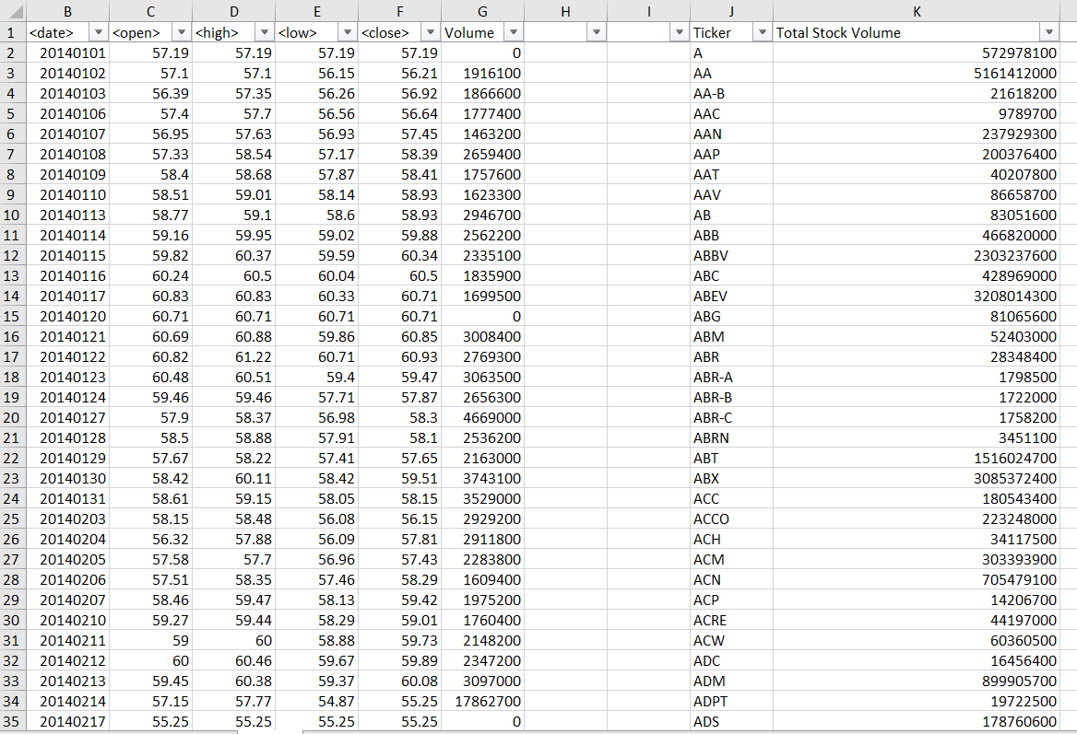

**2015**

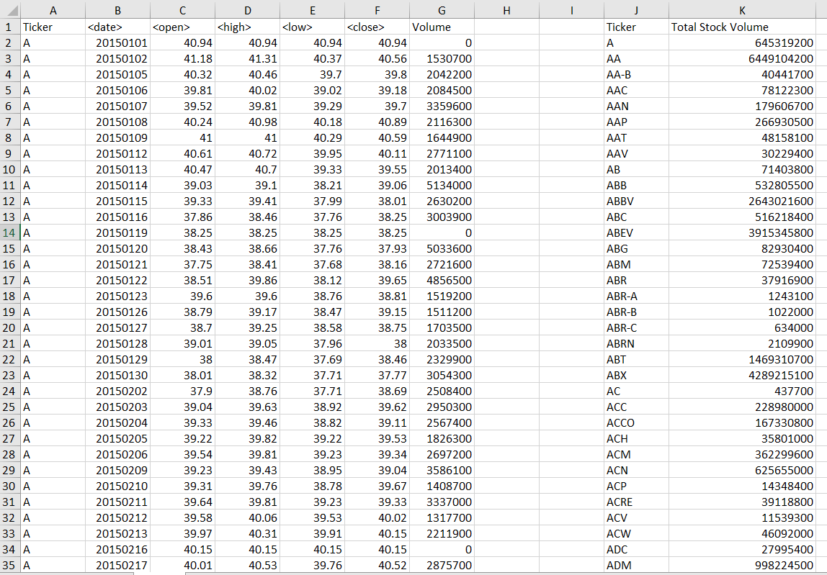

**2016**

